# Report on Mobile Web Client Application

Results

* Browsed "Webform.aspx" on Google chrome to invoke mobile web client on Local Machine
* URL: <http://localhost:64750/Webform.aspx>
* Webpage opened with all text boxes, Labels and Buttons
* User can enter input data in text boxes Input1, Input2
* Page displays output value in the Result box
* Adding two numbers 20, 20 and the result is 40

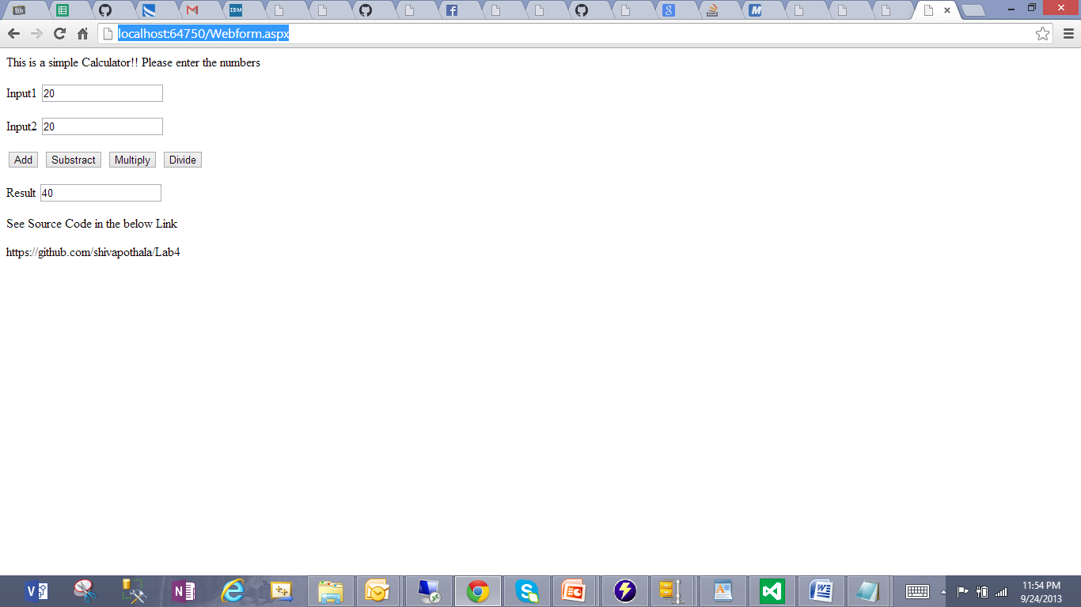

* Subtracting two numbers 20, 20 and the result is 0

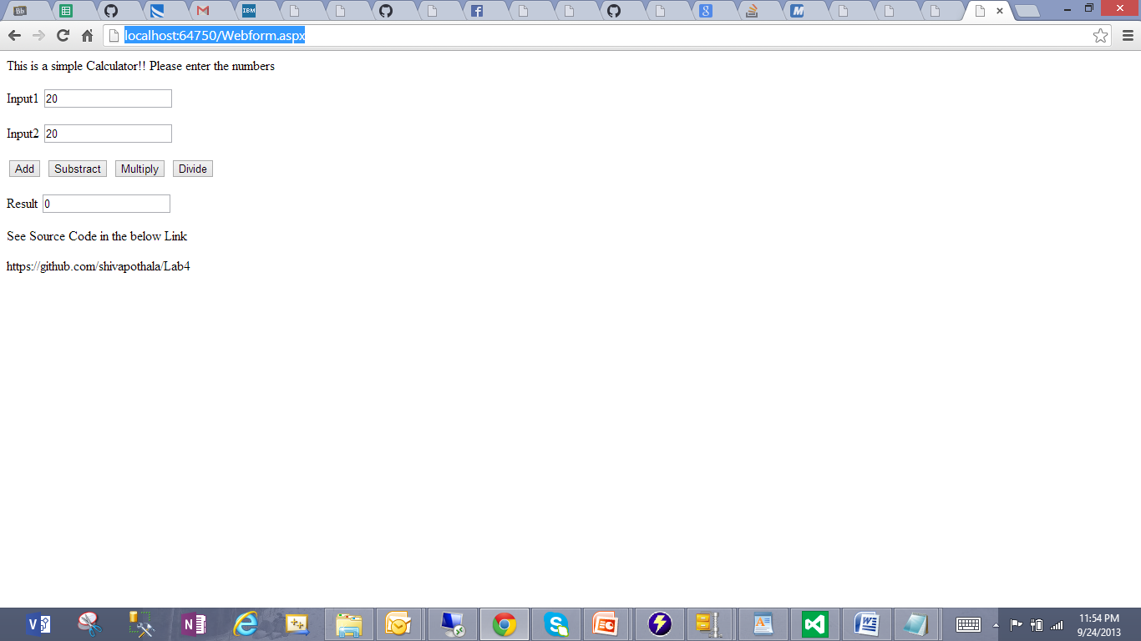

* Multiplying two numbers 20, 20 and the result is 400

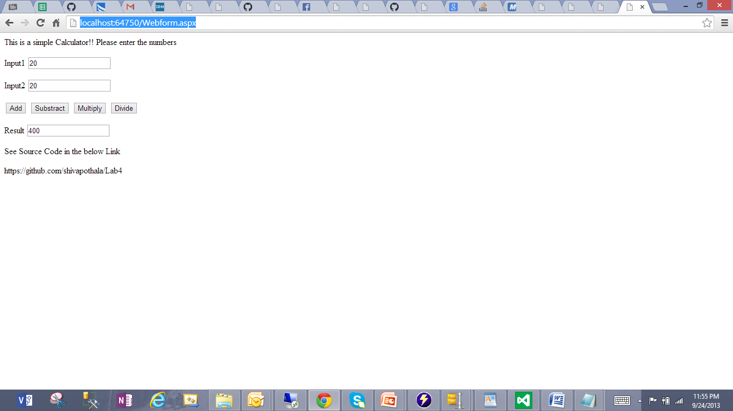

* Dividing two numbers 20, 20 and the result is 1

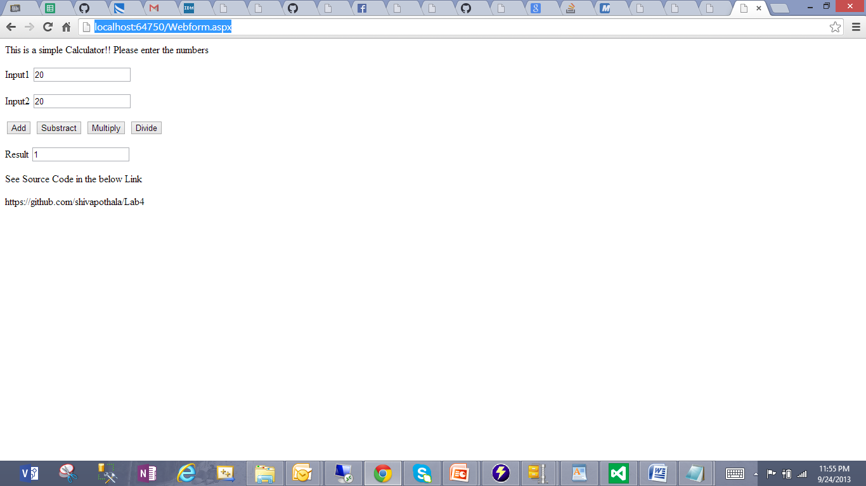

Deployed Web Client source code into IBM Cloud instance

URL: <http://localhost/aspnet_client/ClientWebApp/Webform.aspx>

* Browsed "Webform.aspx" on Google chrome to invoke mobile web client on Local Machine
* Adding two numbers 20, 5 and the result is 25

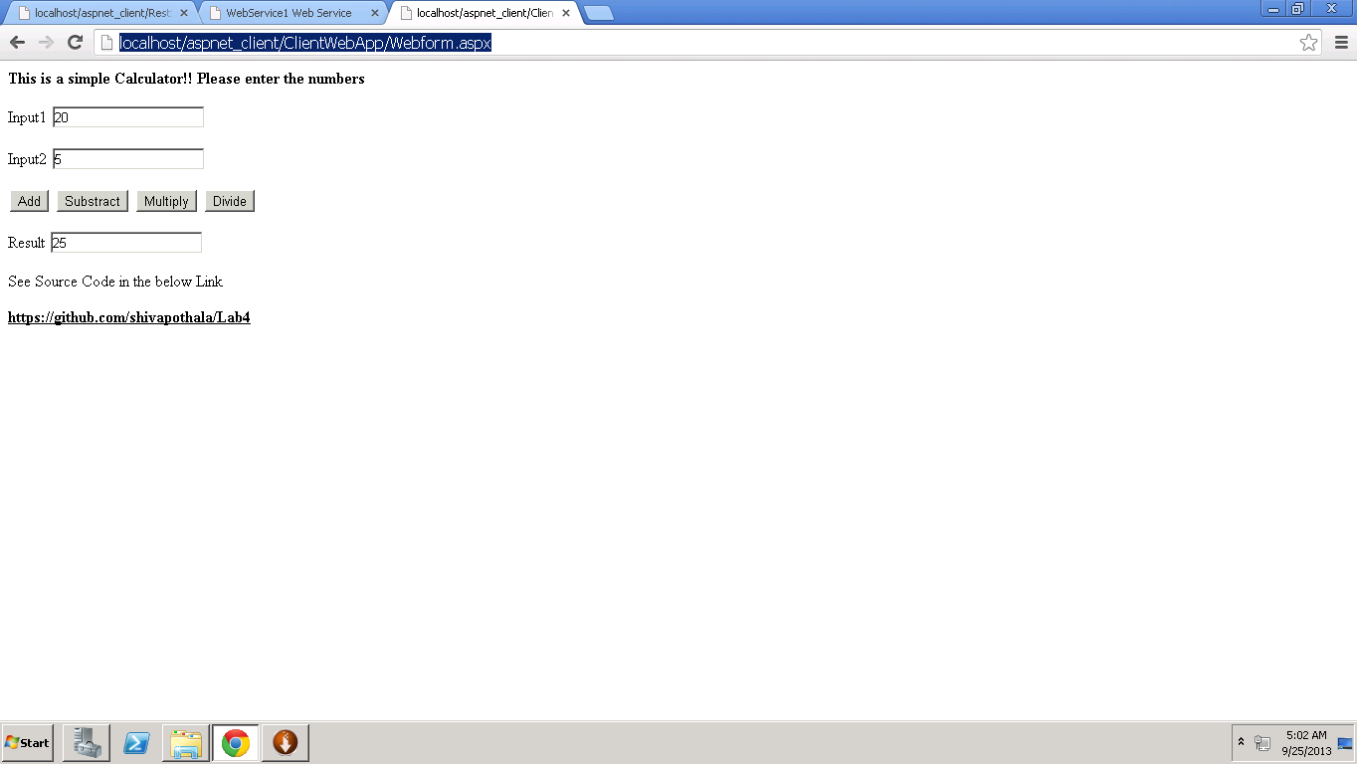

* Subtracting two numbers 20, 5 and the result is 15
* Adding two numbers 20, 5 and the result is 25
* Subtracting two numbers 20, 5 and the result is 15

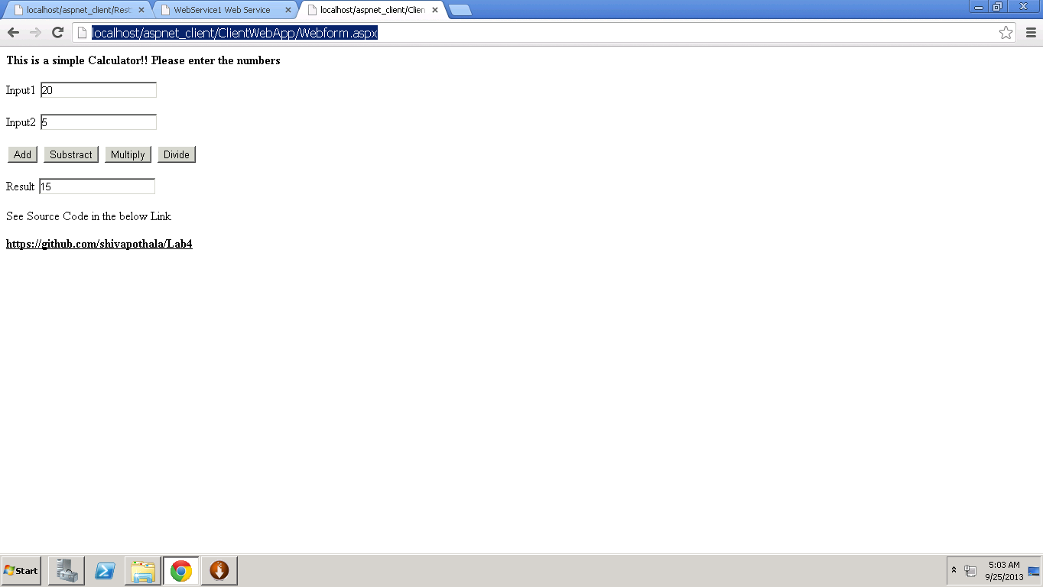

* Multiplying two numbers 20, 5 and the result is 100

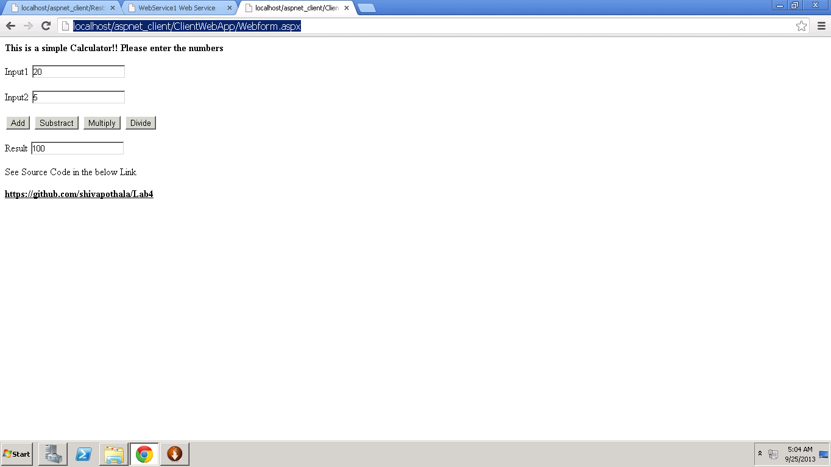

* Dividing two numbers 20, 5 and the result is 4

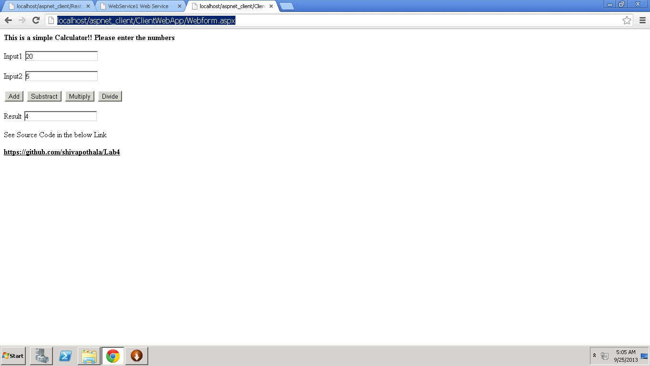

Accessing Remote Client Application from Local Machine with my Cloud Instance IP Address 170.224.163.112

URL: <http://170.224.163.112/aspnet_client/ClientWebApp/Webform.aspx>

* Dividing two numbers 100, 50 and the result is 150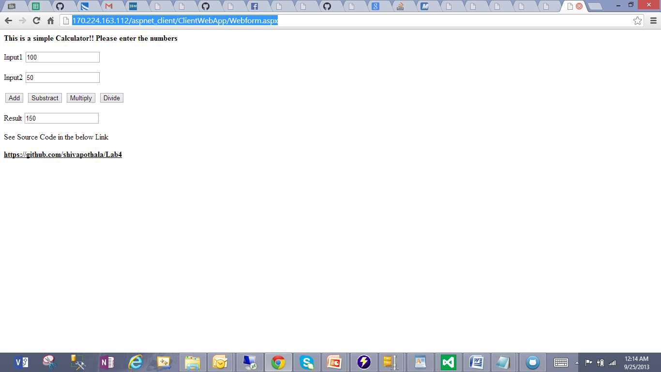
* Subtracting two numbers 100, 50 and the result is 50

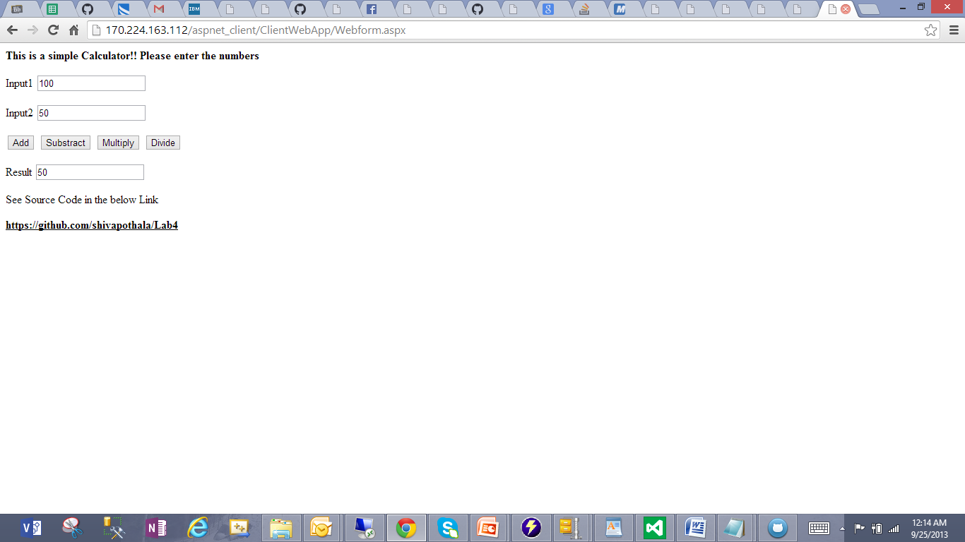

* Multiplying two numbers 100, 50 and the result is 5000

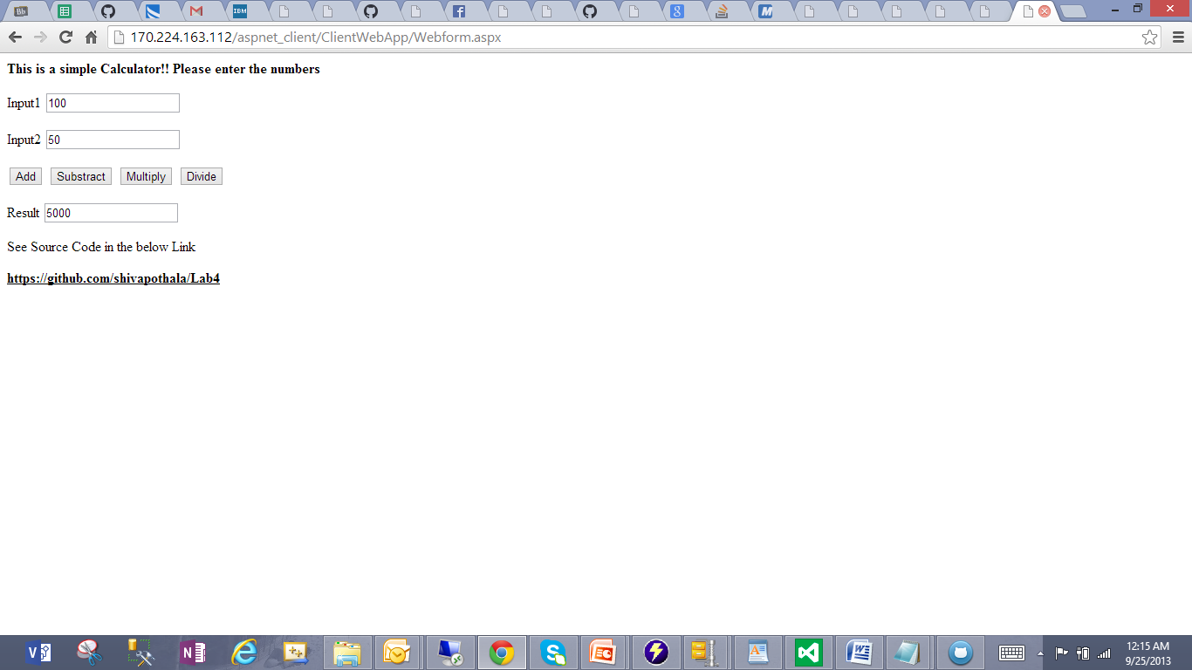

* Dividing two numbers 100, 50 and the result is 2

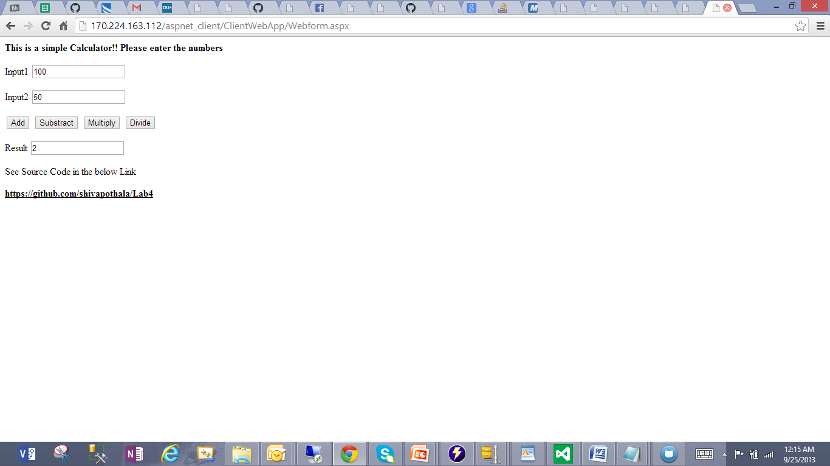

Observations:

* Implemented Web Client Application on my local machine
* Deployed and accessed on IBM Cloud Instance
* Accessed Remote web application from the Local Machine
* Source code works well on both machines